**Humayun’s Tomb Photo Frame Art**

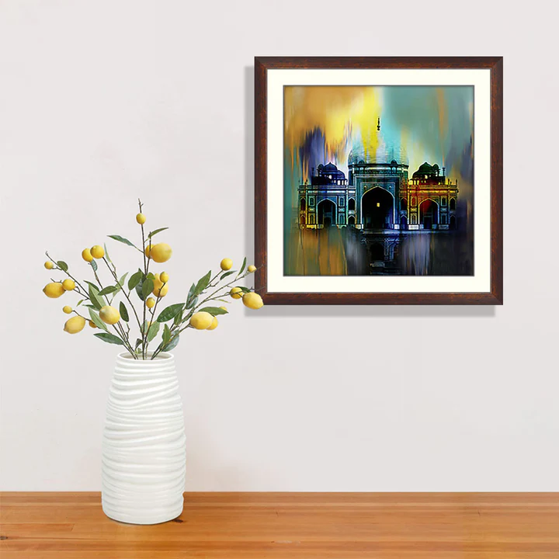Humayun's Tomb, located in Delhi, India, is a stunning example of Mughal architecture and a precursor to the iconic Taj Mahal. Commissioned in 1565 by Emperor Humayun's wife, Empress Bega Begum, the tomb was designed by Persian architect Mirak Mirza Ghiyas. This UNESCO World Heritage Site is characterized by its grand double dome, intricate red sandstone and white marble facade, and symmetrical Persian-style Charbagh gardens, divided by water channels. The tomb's harmonious blend of Persian, Islamic, and Indian architectural styles exemplifies the Mughal dynasty's cultural richness. Surrounded by lush greenery, Humayun's Tomb remains a serene and majestic symbol of love, art, and history.